Implement services for managing Country :
Delete all the records and add the original data from the file.
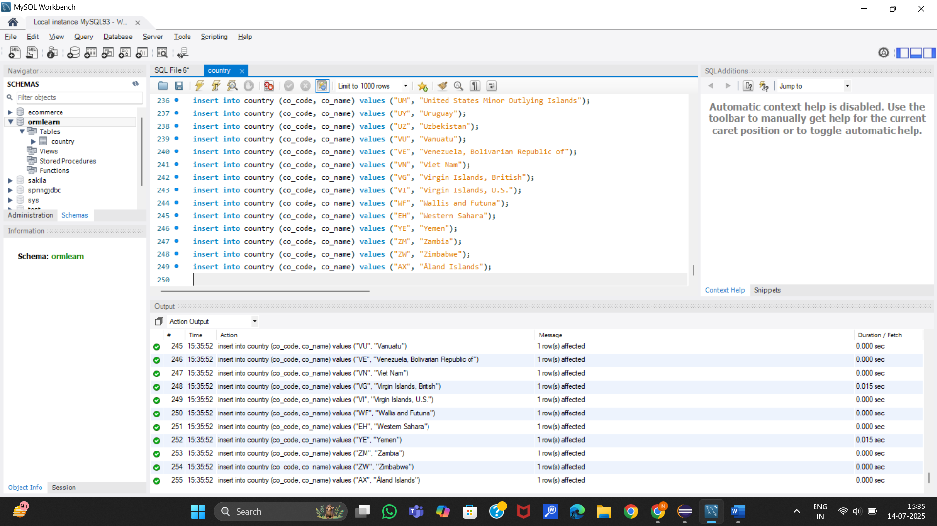
- Find a country based on country code
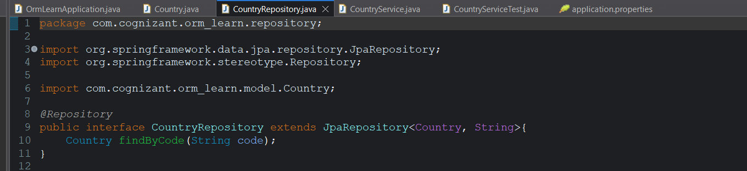
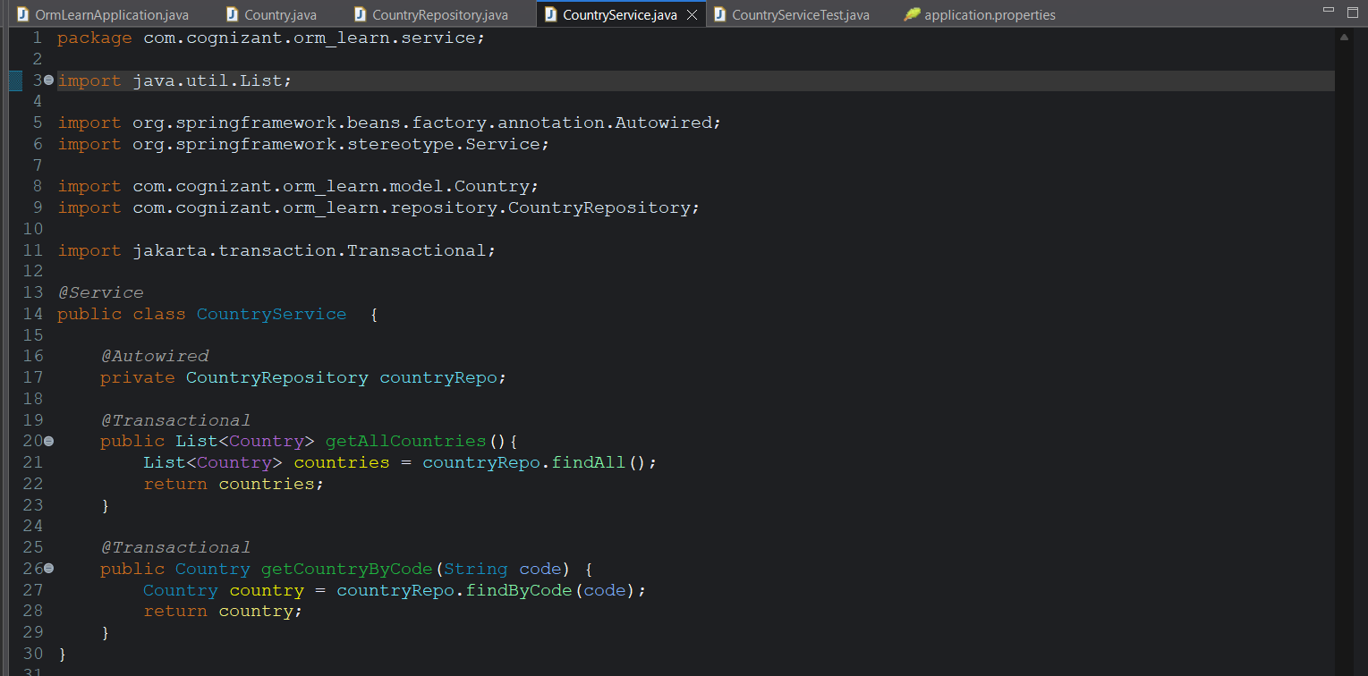
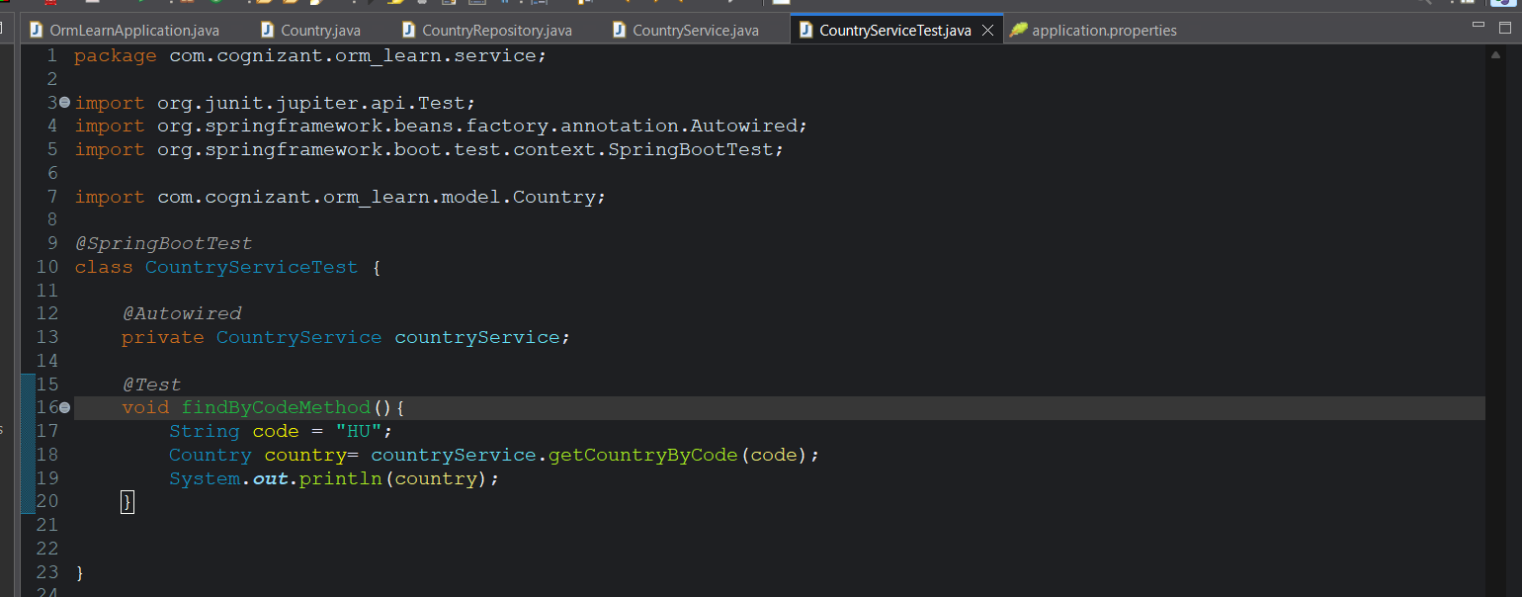
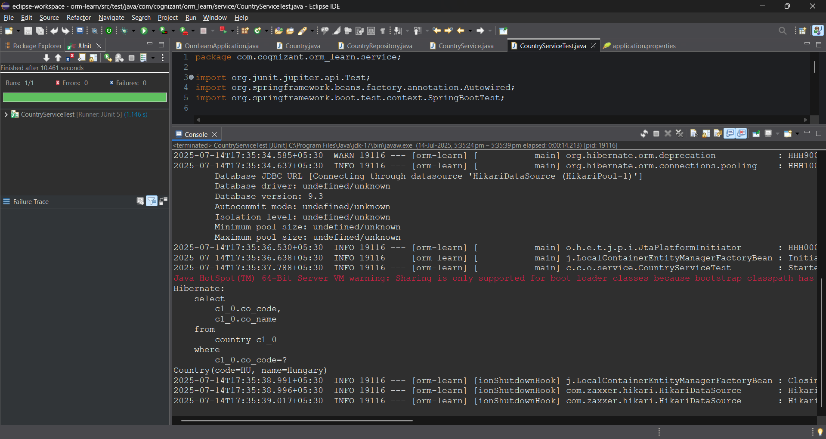
We can see how hibernate creates the query based on the function name.
Since we annotated code as @Id we directly use findById method provided by the JpaRepository
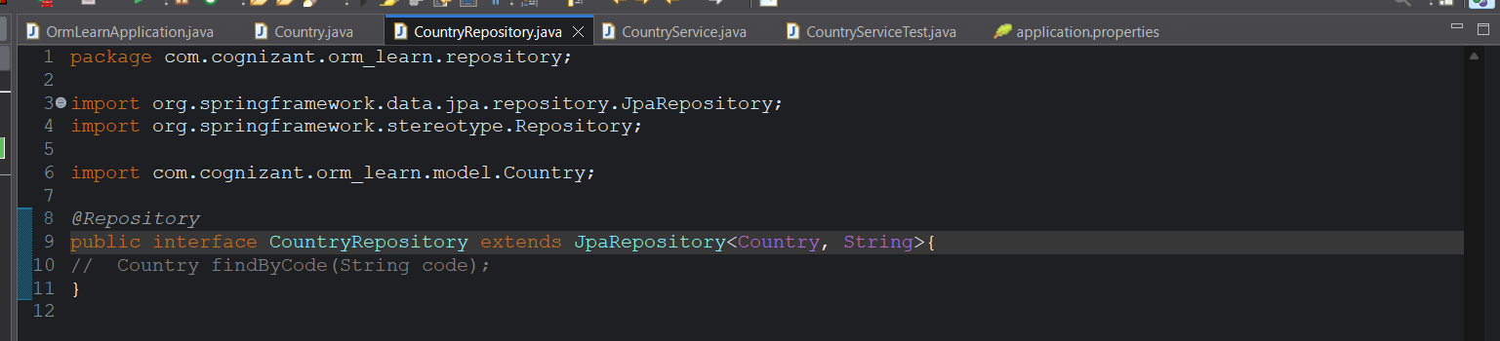

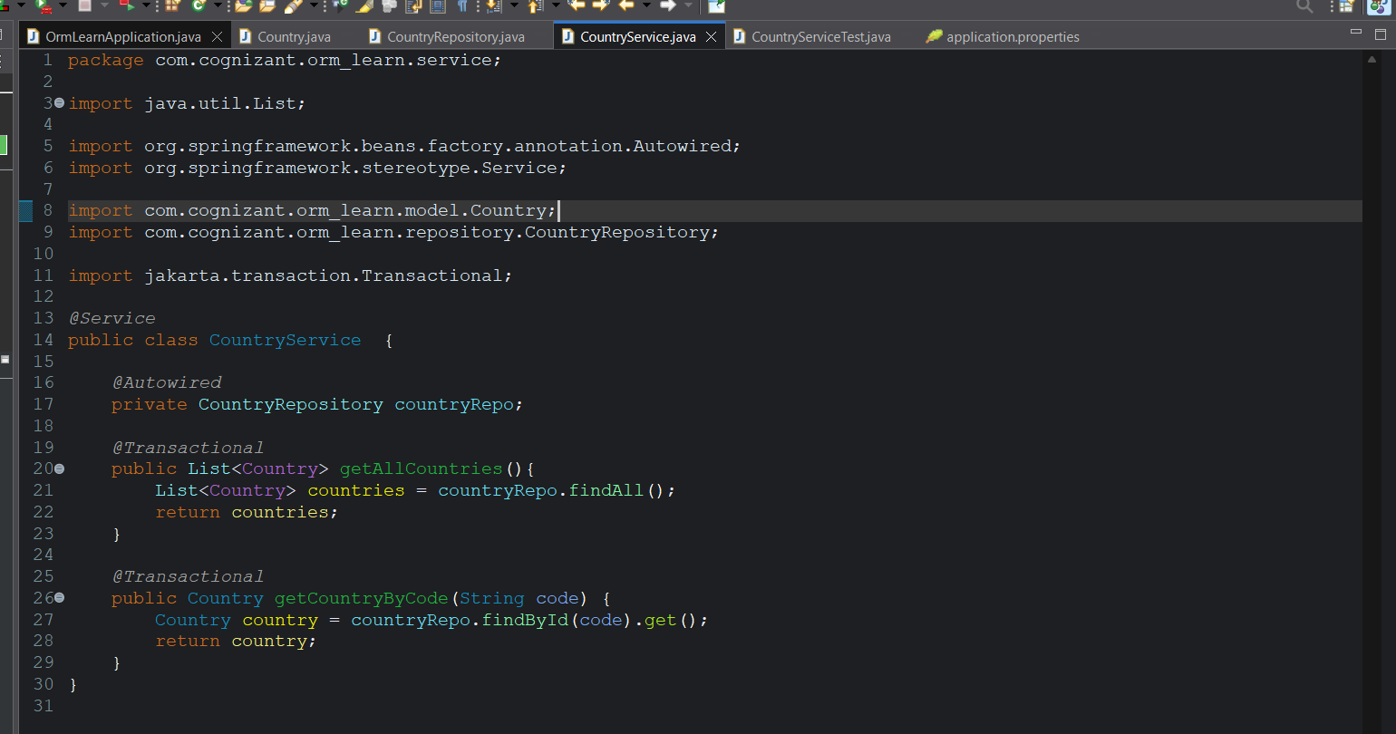
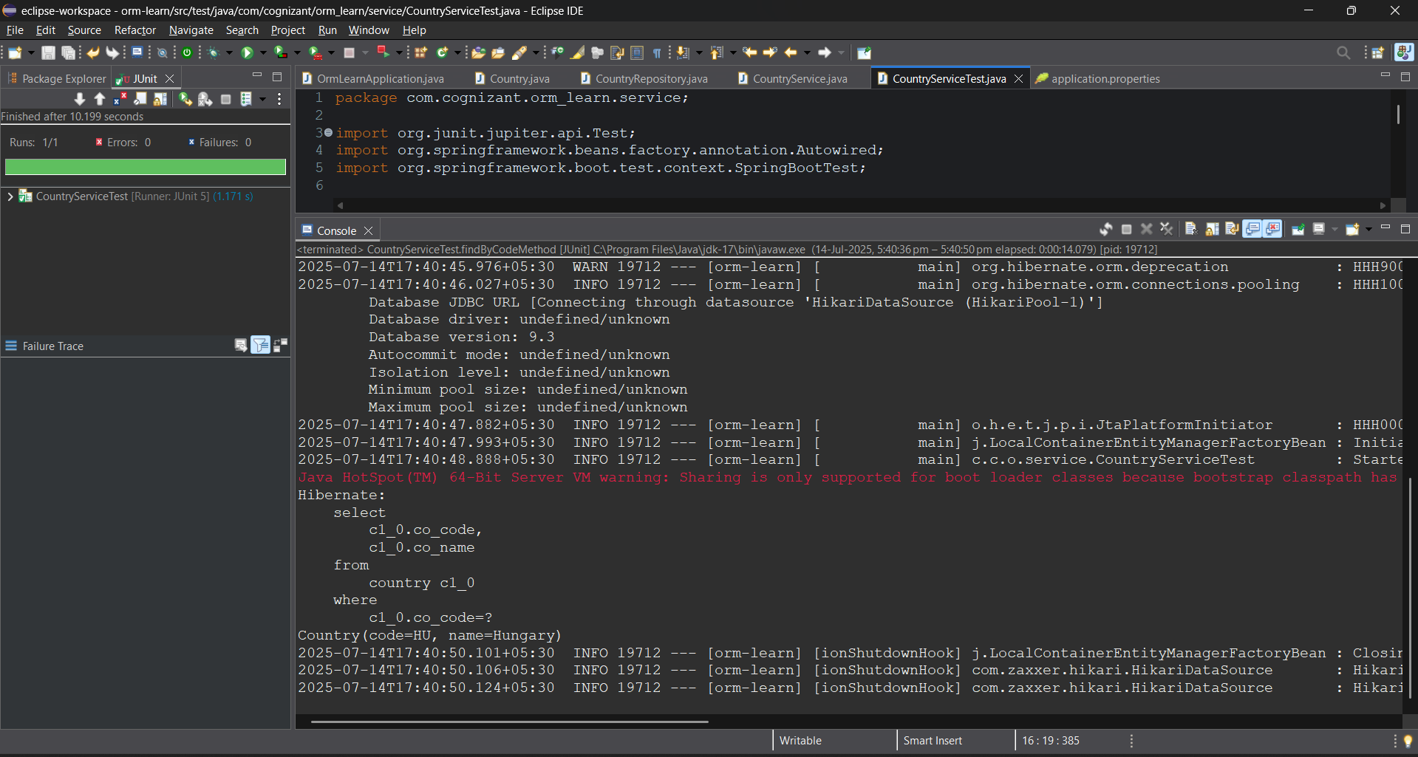
We can see the same output as in the previous case.

- Add new country.
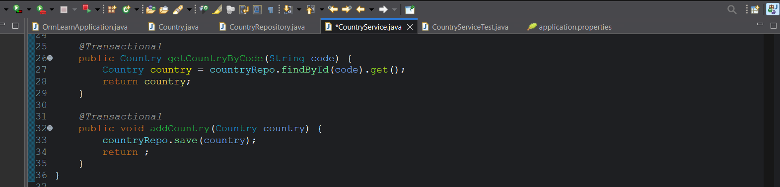
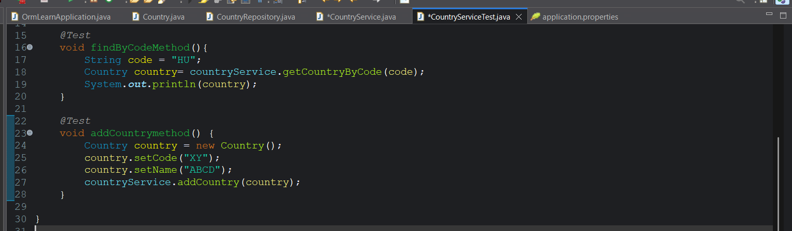
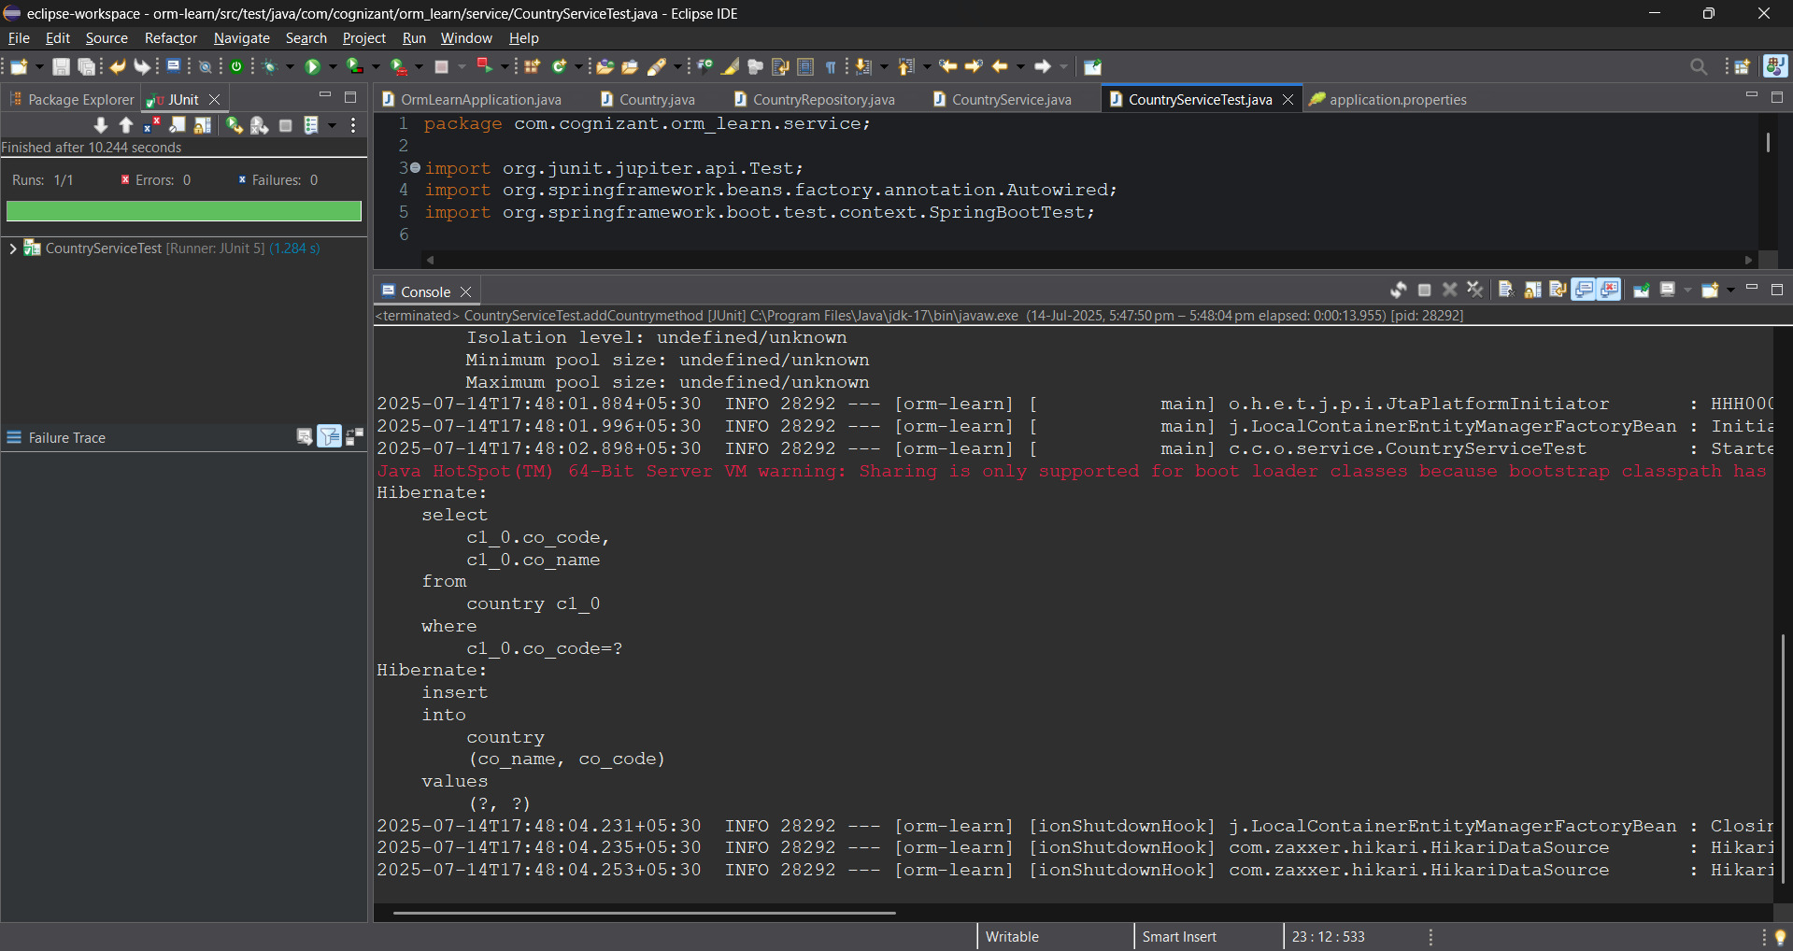
We can see that how the hibernate creates the query to insert a country into the table.
First it selects the table then writes a query to inert a new country.

- Update country
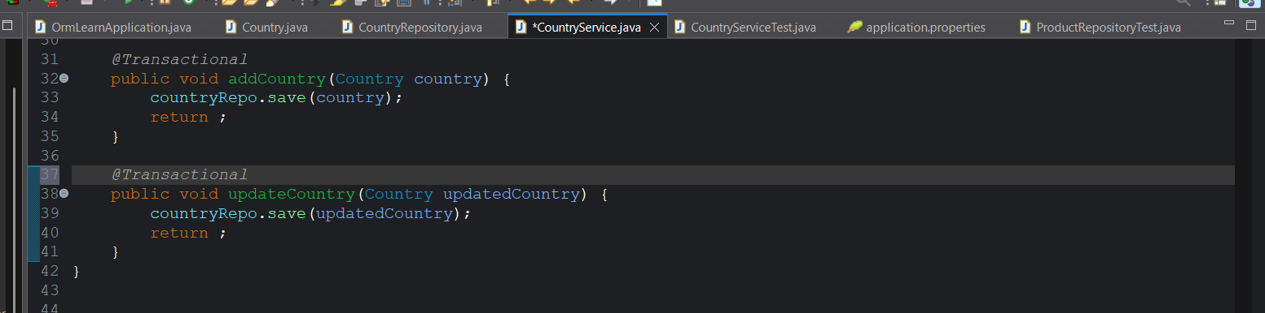
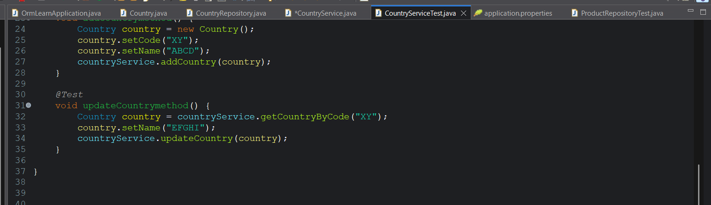
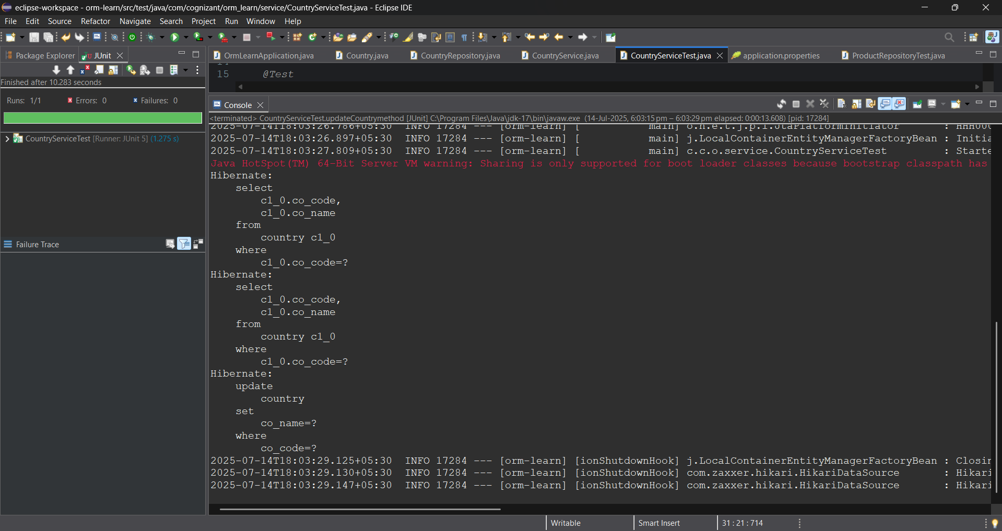
We can see the updated by calling get method.
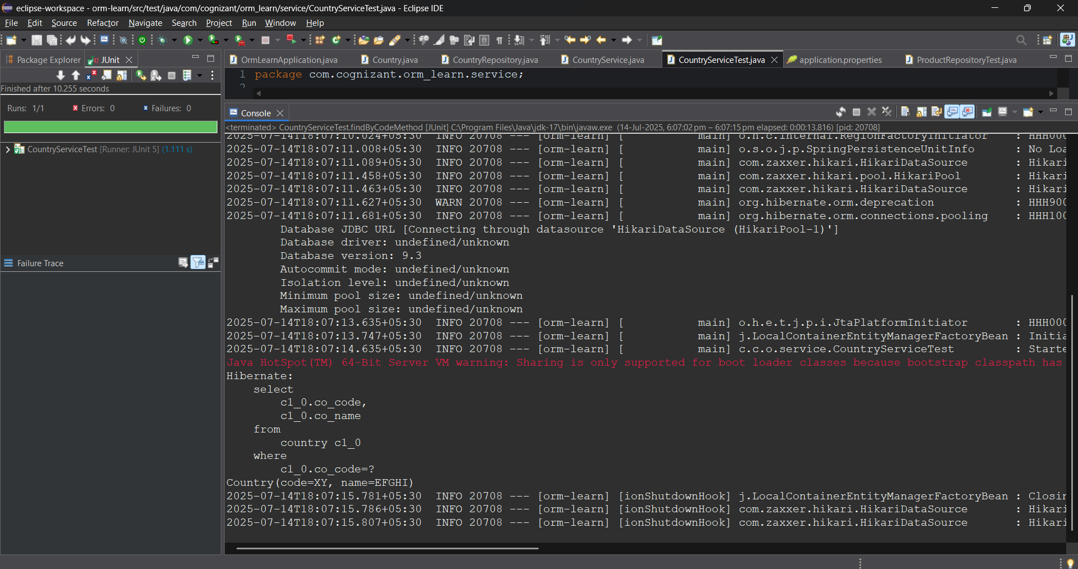

- Delete country
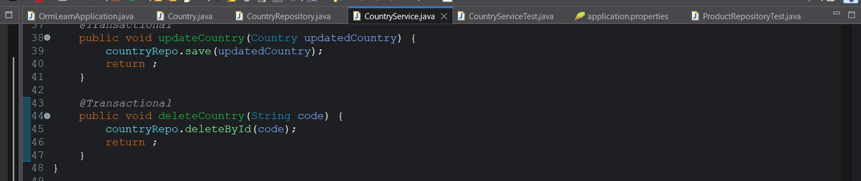
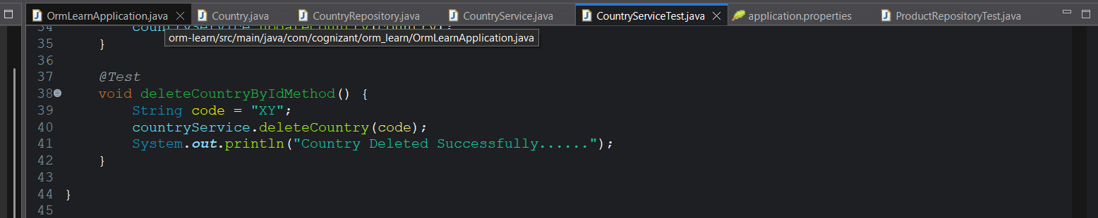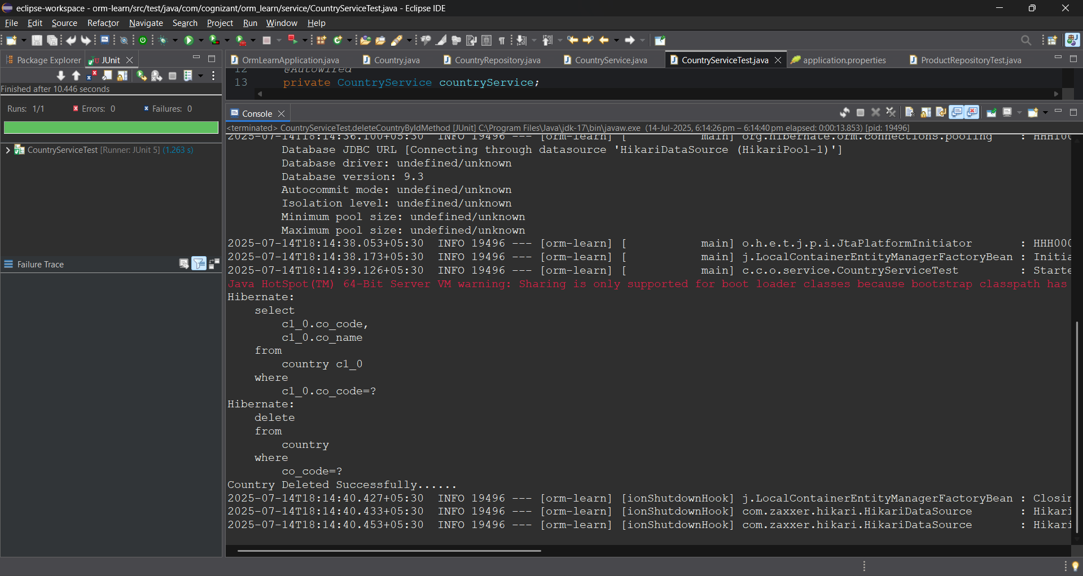

The country with code “XY” is deleted from the database.

- Find list of countries matching a partial country name
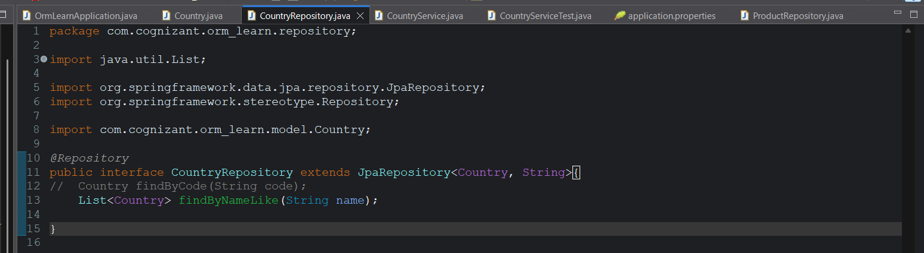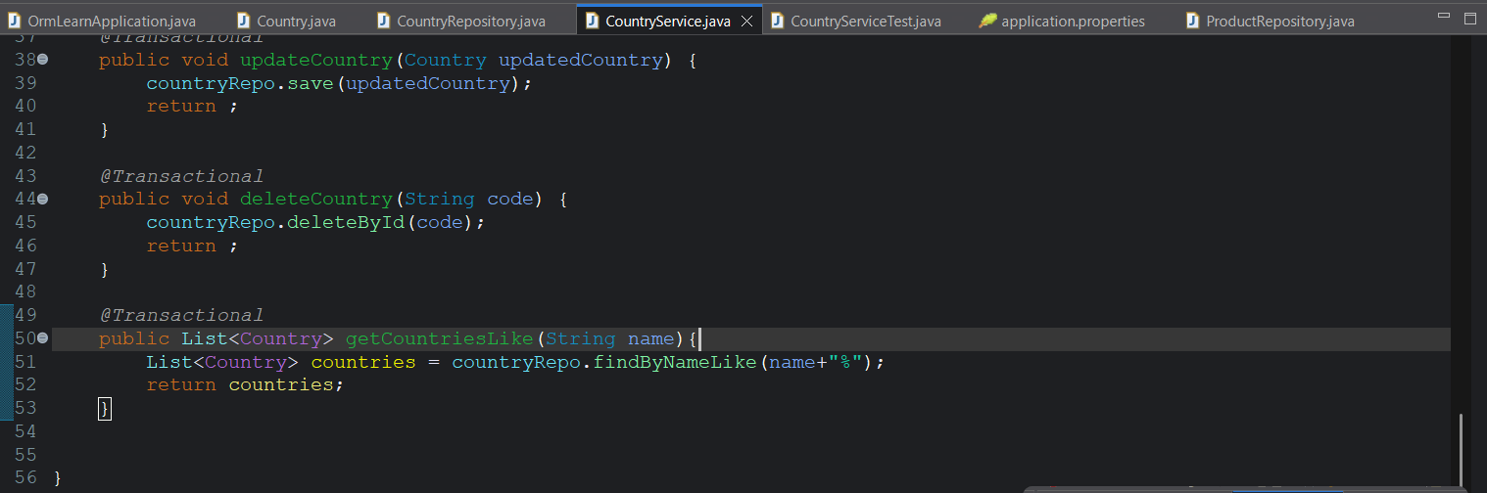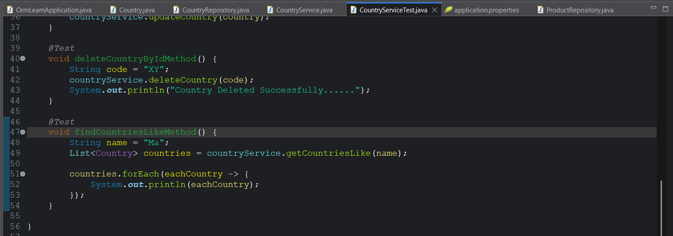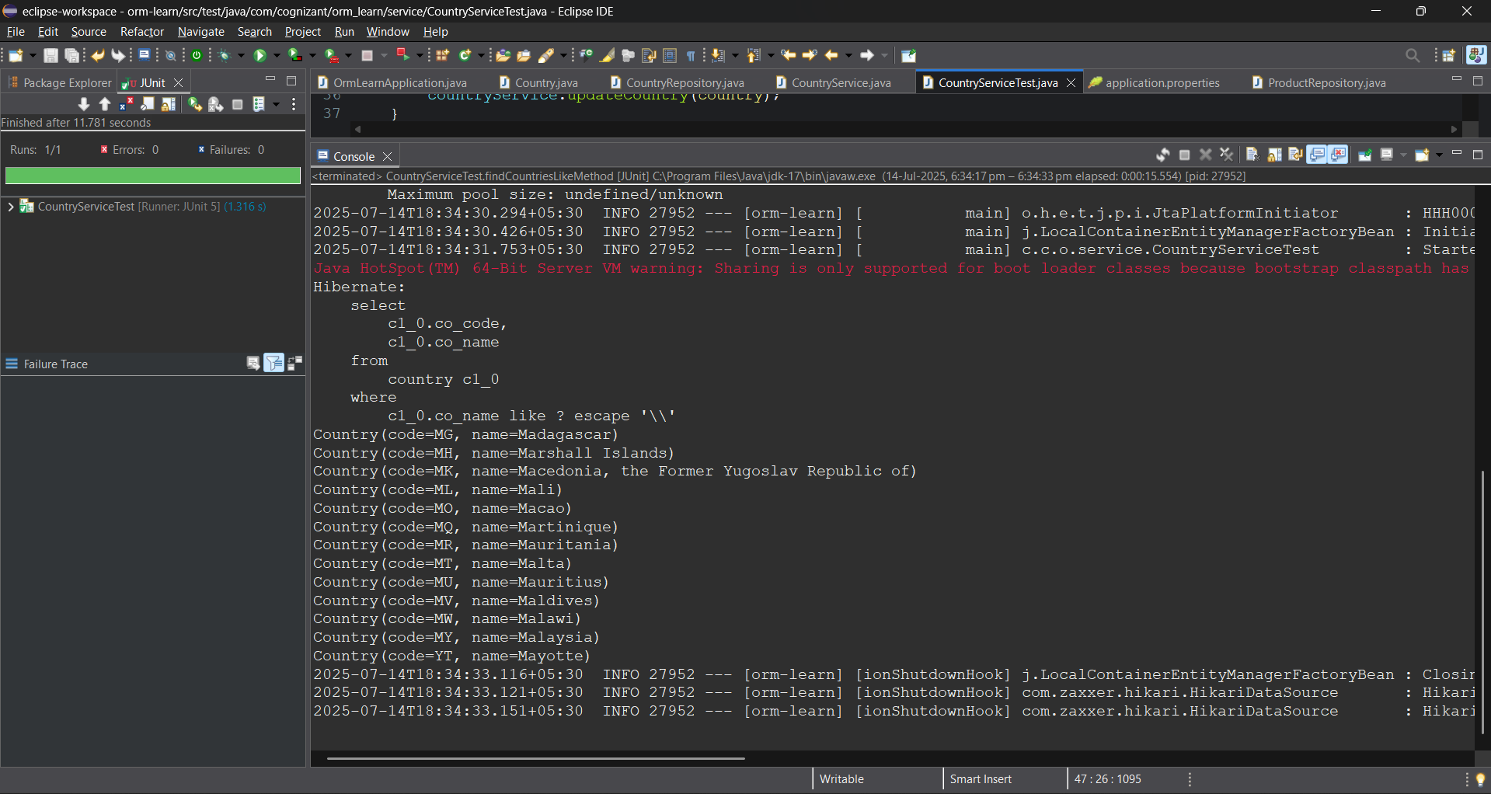
This is how we can perform CRUD operations using spring data jpa.

